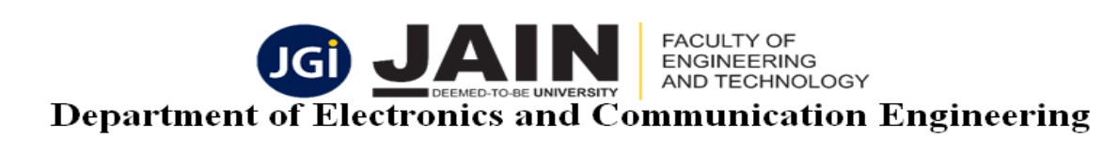
Batch 2018-22/AY 2021-22/G02 Wednesday, June 22, 2022

Smart Attendance Using Face Recognition

ABSTRACT:

A face recognition system is one of the biometric information processes, its applicability is easier and working range is larger than others, i.e.; fingerprint, iris scanning, signature, etc. A face recognition system is designed, implemented and tested. The system uses a combination of techniques in two topics; face detection and recognition. The face detection is performed on live acquired images without any application field in mind. Processes utilized in the system are white balance correction, skin like region segmentation, facial feature extraction and face image extraction on a face candidate. Then a face classification method that uses Feedforward Neural Network is integrated in the system. The system is tested with a database generated in the laboratory with 26 people. The tested system has acceptable performance to recognize faces within intended limits. System is also capable of detecting and recognizing multiple faces in live acquired images
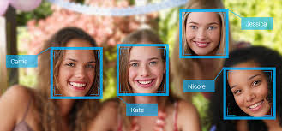
Fig.1 Recognizing image

INTRODUCTION:
The more efficient the attendance system the mare is participation and learning. In the past we were using techniques like roll numbering calling and signing against a particular roll number. These methods carry a high chance of proxy and are time consuming. We came across the idea of automating this process through modern day technologies to get a well maintained and disciplined attendance. Facial recognition systems along with suitable hardware and software will help meet the goals of this project.
The project aims at designing an intelligent security system for recording the attendance in colleges, firms etc..,. The proposed system makes use of Face Recognition technology for recording the attendance. The system records the attendance along with enter and exit date and time. The Intelligent system proposed makes use of MATLAB software to achieve the task.
We are living in a world where everything is automated and linked online. The internet of things, image processing and machine learning are evolving day by day. Many systems have been completely changed due to this evolve to achieve more accurate results. The at`tendance system is a typical example of this transition, starting from the traditional signature on a project sheet to face recognition. In this project we are proposing an automatic attendance system which can be used in every organization to mark the attendance of employees. The main application of Automatic attendance system is seen in teaching institutions, where the attendance of students has to be regularly monitored on daily basis

OBJECTIVES:

To develop a portable Smart Attendance System which is handy and self-powered.

Have enough memory space to store the database.

Able to recognize the face of an individual accurately based on the face database.

Allow new students or staff to store their faces in the database

Able to show an indication to the user whether the face- recognition process is successful or not

SOFTWARE TOOLS USED:
- MATLAB
- IMAGE PROCESSING

METHODOLOGY:

Enrollment Phase

1)Image Acquisition: For Image acquisition, camera is used to capture an image of the employees working in an organization.

2) Face Detection and Face cropping: For face detection cascading algorithm is used. Further face cropping is done using imcrop (image) command that separates the facial area from the rest of the background image. This faces is stored in the database.

3) Feature Extraction: Feature extraction is done by using linear binary pattern algorithm. Feature extraction is helpful for face detection and recognition.

4) Database: Extracted features of employees or persons will be stored in Database

Routine Attendance after Enrollment Phase

Face recognition is done by using the Local binary pattern by taking 3x3 block a time and comparing central block with surrounding blocks and compare with features stored in the database. If after face recognition face of the person is matched in the database then update the attendance otherwise show the dialogbox with invalid person.

FLOW CHART:
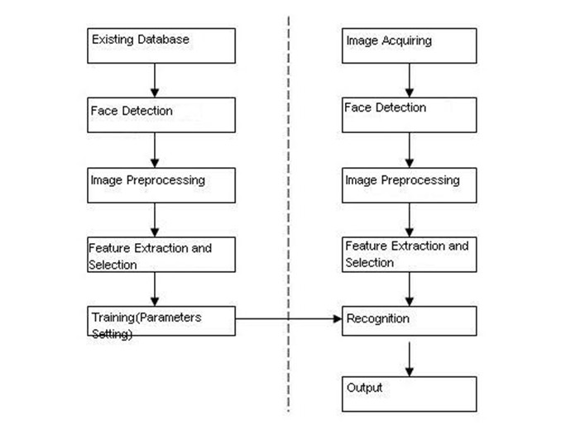

FIG 2: Flowchart of face recognition

RESULTS AND DISCUSSION:

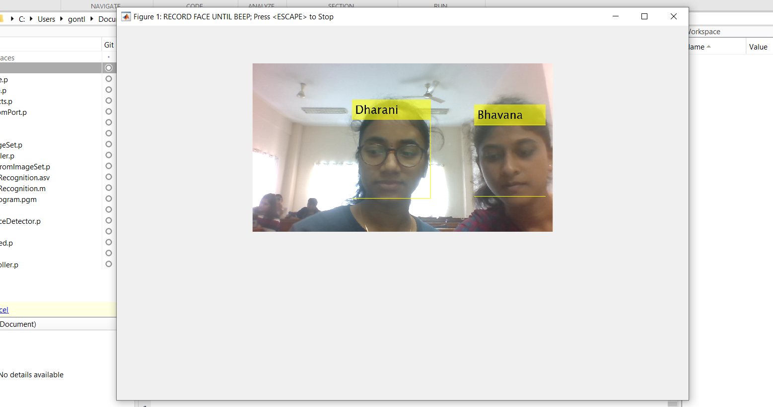

Fig 3 Recognizing the image
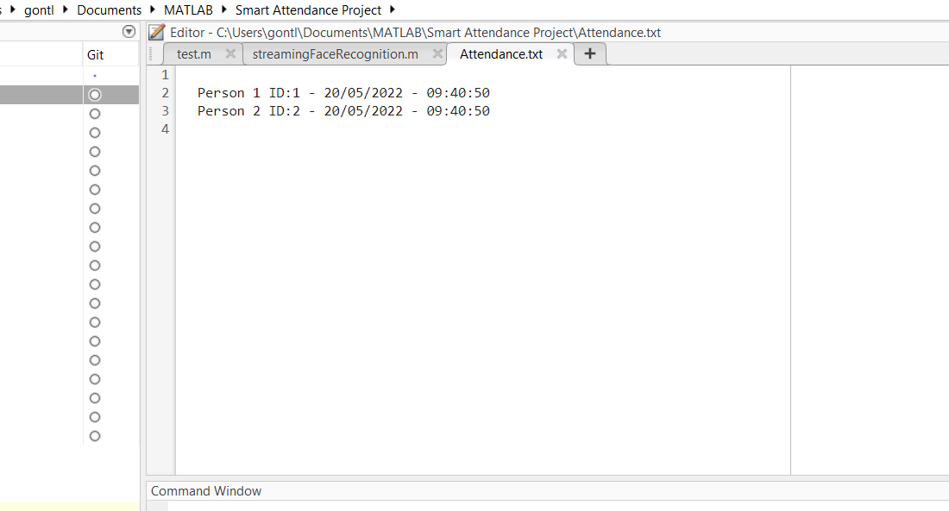

Fig. 4 stored data of image recognized persons.

FUTURE SCOPE:

- Almost all academic institutions require attendance records of students and maintaining attendance manually can be hectic as well as time consuming.
- Hence maintaining attendance automatically with the help of face recognition will be very helpful and less prone to errors as compared to manual process.

Conclusion:
With the advent of fast and cheap machines, digital image processing has become a very highly demanded field of study and practice. It provides solutions to various real-life applications in an economical way.

The project is submitted by
Bhavana. L
E Ajith Bhargav
G Sai Dharani
N Lohithas Reddy
18BTREC010
18BTREC018
18BTREC019
18BTREC046

Under the Guidance of
Dr. R. Sukumar
HOD
Dept. of ECE

